EXECUTIVE FUNCTION MASTER COURSE
ONLINE AT YOUR OWN PACE
SPONSORED BY THE FOUR RIVERS SPECIAL EDUCATION DISTRICT
OPEN TO THE FIRST 20 REGISTRATIONS
WWW.FRSED.ORG UNDER THE PROFESSIONAL DEVELOPMENT TAB
18.5 PD CLOCK HOURS
MUST BE COMPLETED WITHIN 90 DAYS OF ASSIGNMENT

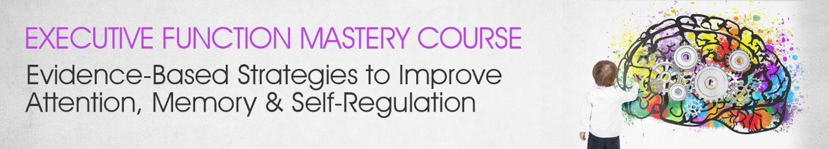
Forgotten appointments, unfinished homework, distractibility, procrastination and difficulties organizing thoughts present intimidating obstacles to make progress for anyone... And the strategies that work so well for others seem to fall short when an executive function (EF) deficit is present.
Your work with individuals struggling with EF concerns may be some of your most rewarding — yet it's often the work that leaves you the most frustrated and exhausted!
Take the mystery out of executive functions for your clients by teaching them how they think, learn and behave to help create an active role in their own development. With a combined experience of over 40 years working with Executive Function, we've partnered with three international experts — George McCloskey, Ph.D. | Lynne Kenney, Psy.D. | Kathy Morris, M.Ed., B.S. — to bring you a comprehensive look into EF, so you can integrate a multidisciplinary approach to promote organization, self-regulation, focus, social-communication, memory and much more.
You'll not only gain effective assessment techniques to determine EF strengths and weaknesses, but you'll also learn how to:
- Analyze a comprehensive neuropsychological model of executive functions as it relates to clinical treatment.
- Implement research-based activities to improve thinking, self-regulation and behavior.
- Communicate how EF deficits are present in those diagnosed with ADHD, anxiety, Autism, dyslexia, ODD and other psychological disorders.
- Incorporate visual strategies to support the way information is received and retained in long-term memory.
Whether you're an OT, SLP, counselor, teacher, or social worker, you'll leave this course feeling confident in your ability to dramatically improve the lives of your clients struggling with EF deficits.
Through video case studies and visual demonstrations, you will walk away distinguished from others in your field when you advance your practice with these EF strategies that you'll be able to merge into your existing approach with ease!

